Methodology
This chapter outlines and expands upon the research methodology and materials used for the formulation and simulation of the model using a genetic algorithm.

Model Formulation
This study aims to modify the existing models in literature. In particular, four models are presented, taking into account the transferability between shelters, sequence of transfer, and distance of shelters to major workplaces. For simplicity, instead of solving using multiobjective optimization techniques, we will instead assign weights $wt_{dist}, wt_{cost}$ such that $wt_{dist}+ wt_{cost}= 1$ to each objective and minimize their weighted sum. These models aim to minimize the total travel distance of evacuees and construction and maintenance cost of shelters in a single objective function. The notations used in the models are defined in Table x.x.
Notations | Definitions
M | number of communities
N | number of candidate shelter sites
d_{ij} | distance of ith community to jth candidate shelter
$${\overline{d}}_{jl}$$ | distance of jth candidate shelter to lth candidate shelter
$${\overline{d}}_{jw}$$ | distance of jth candidate shelter to wth workplace
P_{i} | population of ith community
D_{i} | maximum distance that can be traveled by ith community
β_{i} | portion of the population in ith community that choose to transfer from lower level to higher level shelter
β_{i,W} | portion of the population of ith community that works in wth workplace
C_{j}^{(k)} | cost of constructing and/or maintaining a level k shelter on jth site
Area_{j}^{(k)} | total area of jth candidate site to be used to construct a level k shelter
L | area alloted for each evacuee
MaxL2 | user-defined maximum number of Level 2 shelters to be constructed
MaxSh | user-defined maximum number of shelters to be constructed
$$wt_{dist}, wt_{cost}$$ | weights for distance and cost objective functions, respectively,  $$0 <wt_{dist},wt_{cost} < wt_{dist}+ wt_{cost}= 1$$
x_{ij} | binary decision variable indicating if community j is assigned to shelter i
y_{j}^{(k)} | binary decision variable indicating if shelter j of level k is opened

Bilevel Non-sequential Transfer (BNST) Model
In this model, the evacuees may evacuate to any level of shelter during the initial phase of evacuation. Each community is assigned to exactly one shelter, which may be level 1 or level 2, but not both. After a couple of days, the remaining occupants of a level 1 shelter must transfer to a level 2 shelter while the remaining occupants of a level 2 shelter may or may not transfer to another level 2 shelter. Merging the remaining occupants into a smaller number of shelters eases relief distribution and management.
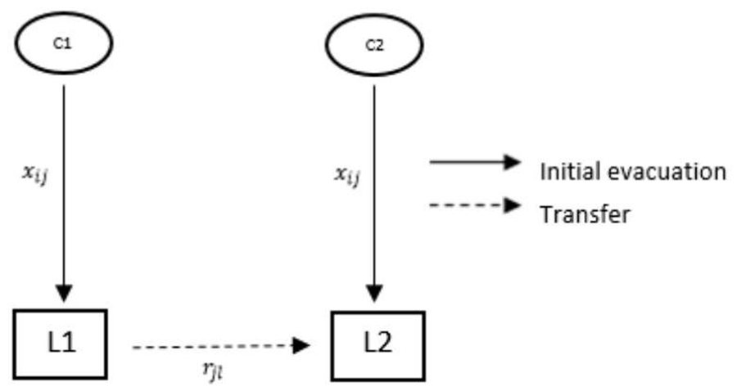
The proposed model is
$$min wt_{dist}\sum_{j=1}^{N}{\left(\sum_{i=1}^{M}{d_{ij}P_{i}x_{ij}+\sum_{l=1}^{N}{{\overline{d}}_{jl}\left(\sum_{i=1}^{M}{β_{i}P_{i}x_{ij}}\right)r_{jl}}}\right)+wt_{cost}\sum_{k=1}^{2}{\sum_{j=1}^{N}{C_{j}^{(k)}y_{j}^{(k)}}}}$$
subject to

$$d_{ij}x_{ij}≤D_{i},∀i=1,…,M,∀j=1,…,N$$
$$\sum_{i=1}^{M}{LP_{i}}x_{ij}≤Area_{j}^{\left(1\right)}y_{j}^{\left(1\right)}+Are{a }_{j}^{\left(2\right)}y_{j}^{\left(2\right)},∀j=1,…,N$$
$$\sum_{i=1}^{M}{\sum_{j=1}^{N}{L{β_{i}P}_{i}}x_{ij}r_{jl}}≤Are{a }_{j}^{\left(2\right)}y_{j}^{\left(2\right)},∀l=1,…,N$$
$$\sum_{j=1}^{N}{y_{j}^{(2)}}≤MaxL2$$
$$\sum_{k=1}^{2}{\sum_{j=1}^{N}{y_{j}^{\left(k\right)}}}≤MaxSh$$
$$\sum_{j=1}^{N}{x_{ij}}=1,∀i=1,…,M$$
$$\sum_{k=1}^{2}{y_{j}^{\left(k\right)}}≤1,∀j=1,…,N$$
$$\sum_{k=1}^{2}{y_{j}^{\left(k\right)}}=\sum_{l=1}^{N}{r_{jl}} ,∀j=1,…,N$$
$$r_{jl}≤y_{j}^{\left(2\right)},∀j=1,…,N, ∀l=1,…,N$$
$$x_{ij},r_{jl},y_{j}^{\left(1\right)},y_{j}^{\left(2\right)}∈\{0,1\},∀i=1,…,M,∀j=1,…,N$$

The first term of objective (2.1) minimizes the total travel distance of evacuees moving from communities to shelters and transferring to higher-level shelters. The second term minimizes the construction and maintenance cost of shelters. Constraint (2.2) represents the distance constraint which ensures that a community is allocated to a nearby shelter. Constraints (2.3) and (2.4) are the capacity constraints. Constraints (2.5) and (2.6) limit the number of Level 1 and Level 2 shelters to be constructed. Constraint (2.7) ensures that a community will be allocated to exactly one shelter. Constraint (2.8) ensures no co-location of shelters. That is, at most one level of shelter may be constructed on each site. Constraint (2.9) relates the variables and . If site is selected as a shelter, then its occupants must be transferred to another shelter, possibly to itself; otherwise no transfer must happen. Constraint (2.10) determines the level of the shelter. If occupants of at least one shelter transfers to shelter , then is a level 2 shelter. Equivalently, this constraint ensures that a occupants of a lower level shelter must transfer to a higher level shelter, but not vice versa. Lastly, constraint (2.11) defines the binary variables of the problem.
Bilevel Sequential Transfer (BST) Model
This model is similar to BNST model , however only level 1 shelters are available for initial evacuation. That is, each community must be initially allocated to a level 1 shelter, then afterwards they are transferred to level 2 shelters. This may be useful if level 2 shelters need more time to be set up for more advanced facilities and medical services such as medical operations.
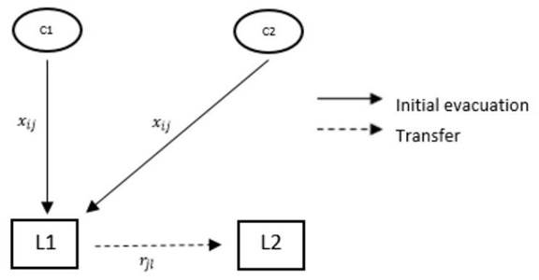
The proposed model is
$$min wt_{dist}\sum_{j=1}^{N}{\left(\sum_{i=1}^{M}{d_{ij}P_{i}x_{ij}+\sum_{l=1}^{N}{{\overline{d}}_{jl}\left(\sum_{i=1}^{M}{β_{i}P_{i}x_{ij}}\right)r_{jl}}}\right)+wt_{cost}\sum_{k=1}^{2}{\sum_{j=1}^{N}{C_{j}^{(k)}y_{j}^{(k)}}}}$$
subject to
$$d_{ij}x_{ij}≤D_{i},∀i=1,…,M,∀j=1,…,N$$
$$\sum_{i=1}^{M}{LP_{i}}x_{ij}≤Area_{j}^{\left(1\right)}y_{j}^{\left(1\right)},∀j=1,…,N$$
$$\sum_{i=1}^{M}{\sum_{j=1}^{N}{β_{i}LP_{i}}x_{ij}r_{jl}}≤Are{a }_{j}^{\left(2\right)}y_{j}^{\left(2\right)},∀l=1,…,N$$
$$\sum_{j=1}^{N}{y_{j}^{(2)}}≤MaxL2$$
$$\sum_{k=1}^{2}{\sum_{j=1}^{N}{y_{j}^{\left(k\right)}}}≤MaxSh$$
$$\sum_{j=1}^{N}{x_{ij}}=1,∀i=1,…,M$$
$$\sum_{k=1}^{2}{y_{j}^{\left(k\right)}}≤1,∀j=1,…,N$$
$$min\left\{1,\sum_{i=1}^{M}{ } x_{ij}\right\}=y_{j}^{\left(1\right)}=\sum_{l=1}^{N}{ } r_{jl}, ∀j=1,…,N$$
$$r_{jl}≤y_{j}^{\left(2\right)},∀j,l=1,…,N$$
$$x_{ij},r_{jl},y_{j}^{\left(1\right)},y_{j}^{\left(2\right)}∈\{0,1\},∀i=1,…,M,∀j,l=1,…,N$$
The objective of this model is the same with the first model. The difference is in the constraints. Constraints (2.13), (2.14), and (2.15) are the distance, level 1 capacity, and level 2 capacity constraints, respectively. Constraints (2.16) and (2.17) limit the number of Level 1 and Level 2 shelters to be constructed. Constraint (2.18) ensures that a community will be allocated to exactly one shelter. Constraint (2.19) ensures no co-location of shelters. Constraint (2.20) relates the variables and and distinguishes this model from the first model. If at least one community is assigned to shelter , then is a level 1 shelter and its occupants must be transferred to another shelter. Constraint (2.21) determines the level 2 shelters. If occupants of at least one shelter are transferred to shelter , then is a level 2 shelter. Consequently, occupants of lower level shelters must transfer to higher level shelters. Lastly, constraint (2.22) defines the binary variables of the problem.
Bilevel No-Transfer (BNT) Model
In this model, two levels of shelters are constructed. However, all communities stay in their assigned shelters throughout the recovery phase and do not transfer at all. This model may be useful when deciding, for instance, whether to build two level 1 shelters or one level 2 shelter. This provides some flexibility for shelter capacities which are otherwise not incorporated in existing models that do not require transferability.
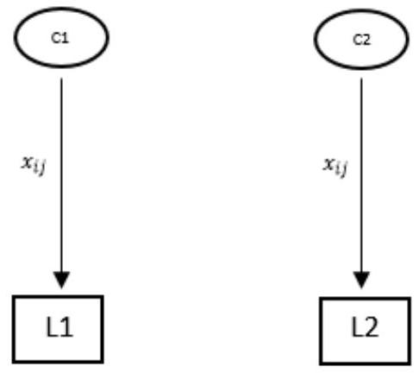
The proposed model is
$$min wt_{dist}\sum_{j=1}^{N}{\sum_{i=1}^{M}{d_{ij}}}P_{i}x_{ij}+wt_{cost}\sum_{k=1}^{2}{\sum_{j=1}^{N}{C_{j}^{\left(k\right)}}}y_{j}^{\left(k\right)}$$
subject to
$$d_{ij}x_{ij}≤D_{i},∀i=1,…,M,∀j=1,…,N$$
$$\sum_{i=1}^{M}{LP_{i}}x_{ij}≤\sum_{k}{Area_{j}^{\left(k\right)}y_{j}^{\left(k\right)}},∀j=1,…,N,k=1,2$$
$$\sum_{j=1}^{N}{y_{j}^{(2)}}≤MaxL2$$
$$\sum_{k=1}^{2}{\sum_{j=1}^{N}{y_{j}^{\left(k\right)}}}≤MaxSh$$
$$\sum_{j=1}^{N}{x_{ij}}=1,∀i=1,…,M$$
$$\sum_{k=1}^{N}{y_{j}^{\left(k\right)}}≤1,∀j=1,…,N$$
$$x_{ij},y_{j}^{\left(1\right)},y_{j}^{\left(2\right)}∈\{0,1\},∀i=1,…,M,∀j=1,…,N$$
The first term of objective (2.23) minimizes the total travel distance while the second term minimizes the construction/maintenance cost of shelters. Constraints (2.24) and (2.25) are the distance and capacity constraints. Constraints (2.26) and (2.27) limit the number of Level 1 and Level 2 shelters to be constructed. Constraint (2.28) ensures that each community is assigned to exactly one shelter. Constraint (2.29) ensures that at most one level of shelter can be constructed at each site. Constraint (2.30) again defines the binary variables of the problem.
Single-level with Workplace Distance Inclusion
Hierarchical shelters are not incorporated in this model for simplicity. Instead of the usual distance minimization objective, this model aims to minimize as well the distance of communities to companies where majority of the residents work. This now allows some communities to be allocated to a farther shelter but closer to their work and other communities are given the chance to be allocated to nearer shelters. This may address the problem of being indiscriminately assigned to a farther shelter.
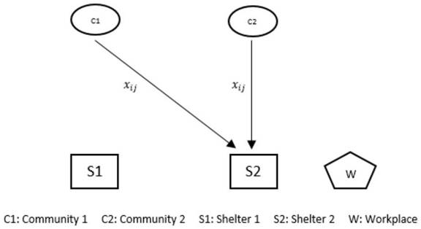
The proposed model is
$$\begin{aligned}{min wt}_{\text{dist} }\sum_{i=1}^{M}{ } \sum_{j=1}^{N}{ } d_{ij}P_{i}x_{ij}+{wt}_{\text{workdist} }\sum_{i=1}^{M}{ } \sum_{j=1}^{N}{ } \sum_{w=1}^{W}{ } {\overset{‾}{d}}_{jw}β_{i,w}P_{i}x_{ij}+{wt}_{\text{cost} }\sum_{j=1}^{N}{ } C_{j}y_{j}\#\end{aligned}$$
subject to
$$d_{ij}x_{ij}≤D_{i},∀i=1,…,M,∀j=1,…,N$$
$$\sum_{i=1}^{M}{LP_{i}x_{ij}}≤\sum_{k}{Area_{j}y_{j}^{\left(k\right)}},∀j=1,…,N$$
$$\sum_{j=1}^{N}{y_{j}}≤MaxSh$$
$$\sum_{j=1}^{N}{x_{ij}}=1,∀i=1,…,M$$
$$x_{ij},y_{j},∈\{0,1\},∀i=1,…,M,∀j=1,…,N$$
The first term of objective (2.31) minimizes the sum of the distances of communities to shelters and workplaces while the second term minimizes the construction and/or maintenance costs. Constraints (2.32) and (2.33) are the distance and capacity constraints. Constraint (2.34) limits the number of shelters to be constructed. Constraint (2.35) ensures that each community is assigned to exactly one shelter. Constraint (2.36) defines the binary variables of the problem.

Solution Techniques
In a study created by Mathew (2012), Genetic Algorithms (GA) are based on the concept of natural selection and evolves possible solutions through selection, crossover, and mutation. The algorithm iteratively evolved a population of potential solutions, gradually converging toward an optimal solution. The models were solved using Integer-based Genetic Algorithm implemented in Python. This decision satisfies the assignment constraints of the models, and with Python being a well-suited programming language for data simulation. For this study, the selection, crossover, and mutation used are roulette wheel, uniform, and random reset respectively.
Penalty function method is used to handle the constraints of the problem. In particular, Courant-Beltrami penalty function method is used to incorporate the constraints into the objective function and transform the problem into an unconstrained minimization problem. A Courant-Beltrami penalty function is written as
$$h\left(x\right)={\left(g^{+}\left(x\right)\right)}^{2}$$
where
$$g^{+}\left(x\right)=max\{g\left(x\right){,0\}}^{2}$$
where g(x) is a constraint function of the form g(x) ≤ 0. When the penalty functions are incorporated into the objective function, the unconstrained model that will be input into GA is
$$f_{new}\left(x\right)=f\left(x\right)+γ\sum_{i=1}^{n}{{(max\{g\left(x\right),0\})}^{2}}$$
where g₁(x), g₂(x), ..., g_{n}(x) are the constraints of the model of the form g_{i}(x) ≤ 0 and $γ∈R^{2}$ is sufficiently large. If the constraints are violated, then the penalty function worsens the objective function value. However, if the constraints are satisfied, the penalty function does not affect the value of the original objective function. For our case study, we used $γ={10}^{20}$. Furthermore, we set $wt_{dist}= wt_{cost}= 0.5$ for BNST, BST, and BNT models since the simulated values for the travel distances and construction costs are not too far from each other. The weights for the WORK model are set to $wt_{workdist}= 0.4, wt_{dist}= wt_{cost}= 0.3$ to put more priority to distance from a workplace.

Case Sources
Table x presents all the data variables on communities, shelters, and workplaces used in the model, along with their respective sources. Researches added empty lots across Calumpit to be appended to shelter data as shown in table x. These lots are identified and selected to be resistant to hazards, with the assistance of Nationwide Operational Assessment of Hazards (NOAH) website.

The four proposed models were implemented in a case study focused on the municipality of Calumpit, Bulacan, and were solved using genetic algorithm described in earlier sections. Constraint handling was managed using the penalty function method.
Study Area. Calumpit, located in the province of Bulacan, is widely recognized as the most flood-prone municipality in the province and possibly in the entire Philippines. Based on the 2020 Census, the municipality had a total population of 118,471 distributed across 29 barangays.
Candidate Shelters. A total of twenty-two (22) existing structures—including covered courts, barangay halls, designated evacuation centers, and schools—were identified within Calumpit as potential shelters. In addition, several vacant lots were considered as backup options in the event that the designated shelters lacked sufficient capacity. In the simulation, level 2 shelter capacities were assumed to be double that of their level 1 counterparts.
Communities. All 29 barangays of Calumpit were treated as individual communities. It was assumed that 12% of the population in each barangay would evacuate to shelters, based on the study of Opdyke et al. (2024) indicating that roughly 12% of residents sought refuge during a typhoon in 2022. Figure x.x presents a map of Calumpit, sourced from OpenStreetMap, showing green markers for communities and blue markers for shelters. A comprehensive list of community and shelter names is provided in the Appendix x.
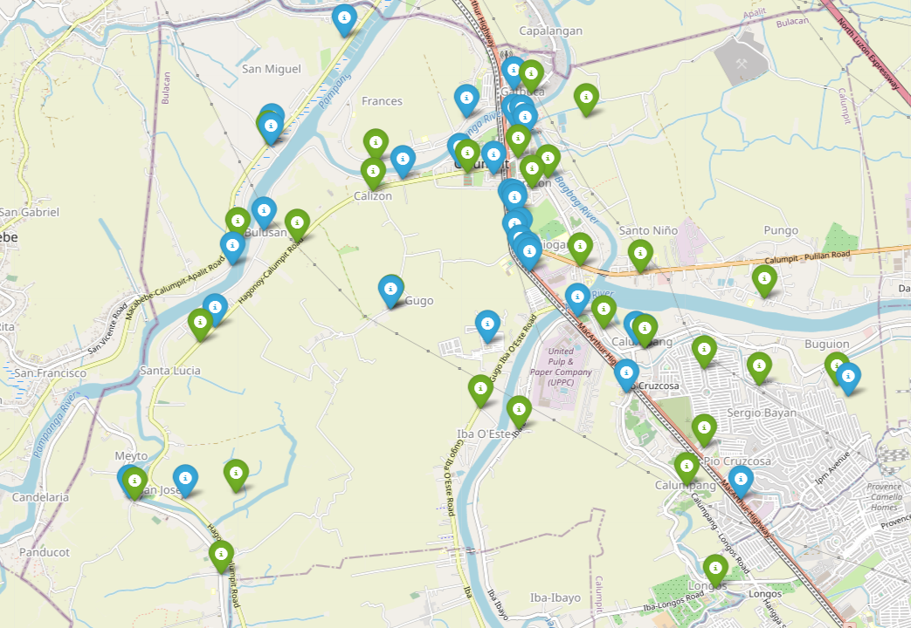
Evacuation Distance. Distances between communities, shelters, and workplaces were calculated along road network paths using the A* algorithm in OpenStreetMap, with the haversine formula applied as the heuristic to estimate straight-line distances. To simplify the model, a generously large maximum travel distance was assigned, assuming that any community would be willing to evacuate to any shelter within the municipality of Calumpit.
Workplace Consideration. In the WORK model, evacuation routes were influenced by the proximity to major workplaces. A total of 13 significant workplaces within Calumpit were identified. All workplaces were grouped together as a single workplace by averaging to streamline the model formulation.
Cost Estimates. Existing shelters are assumed to sustain only maintenance costs at PHP 7,700 per square meter. When upgraded to level 2, a construction cost of PHP 60,000 per square meter is assumed. For empty lots, since the cost of the land is considered, PHP 12,500 per square meter is assumed. All of these cost assumptions are based on contracts and projects of the DILG and DPWH in the Philippines.

Results and Discussion
This study aims to demonstrate that a nondeterministic approach, specifically genetic algorithm (GA), can effectively solve the proposed location-allocation models. For each model, the GA was executed 10 times using Python, and the solution with the lowest objective function value was selected as the optimal result. The minimization criterion was applied because the objective of the models is to reduce total travel distance rather than maximize it.

The problem setup includes 29 communities and 33 potential shelters, with a total population of 118,471. It is assumed that a maximum of 12% of each community's population would evacuate, based on prior evacuation data. Shelter capacity was modeled such that level 2 shelters have twice the capacity of level 1 shelters. Since all shelters and communities are located within the boundaries of Calumpit, an arbitrarily large maximum allowable distance was defined, making distance constraints non-restrictive. As a result, feasible solutions were found for all models under these assumptions. Table x.x outlines the parameters used for the simulation.
Parameters | BNST | BST | BNT |  | WORK
Max. Generations | 10000 | 10000 | 10000 |  | 10000
Population Size | 100 | 100 | 100 |  | 100
Mutation Rate | 0.2 | 0.2 | 0.2 |  | 0.2
Max Shelters | 33 | 33 | 33 |  | 33
Max Lvl2 Shelters | 33 | 33 | 33 |  | 33
Area per Individual (m²) | 1 | 1 | 1 |  | 1
BNST model solution | Obj. func. value | # of generations when solution last updated |  | Run time
1 | 310660775 | 3262 |  | 4m 22s
2 | 265956390 | 5215 |  | 4m 19s
3 (best) | 263670927 | 1177 |  | 4m 42s
4 | 393928730 | 4794 |  | 4m 32s
5 | 374021055 | 2030 |  | 4m 25s
6 | 374745257 | 8070 |  | 4m 29s
7 | 300985709 | 5724 |  | 4m 34s
8 | 349900414 | 1422 |  | 4m 23s
9 (worst) | 580134592 | 1065 |  | 4m 25s
10 | 451795451 | 1776 |  | 4m 31s

BST model solution | Obj. func value | # of generations when solution last updated | Run time
1 (best) | 169312256 | 4909 | 4m 29s
2 | 236716032 | 4304 | 4m 21s
3 | 221954048 | 7483 | 4m 28s
4 | 245448704 | 7700 | 4m 24s
5 | 228737024 | 5860 | 4m 2s
6 | 300613632 | 5783 | 4m 25s
7 | 268992512 | 7924 | 4m 25s
8 | 260308992 | 5124 | 4m 43s
9 | 280756224 | 7453 | 4m 38s
10 (worst) | 310706176 | 3132 | 4m 44s

BNT model solution | Obj. func. value | # of generations when solution last updated | Run time
1 | 176402769 | 1814 | 3m 10s
2 (worst) | 256394606 | 6911 | 3m 9s
3 | 157354975 | 8198 | 3m 14s
4 | 57713859 | 4335 | 3m 11s
5 | 155970494 | 5578 | 3m 11s
6 | 122341646 | 4107 | 3m 2s
7 | 75967050 | 9774 | 3m 2s
8 | 121725237 | 9524 | 3m 12s
9 (best) | 57666363 | 9450 | 3m 2s
10 | 64660700 | 3305 | 3m 3s

WORK model solution | Obj. func. value | # of generations when solution last updated | Run time
1 | 72994534 | 7780 | 2m 33s
2 | 72544698 | 9700 | 2m 37s
3 | 71155803 | 5890 | 2m 34s
4 (worst) | 91364172 | 7428 | 2m 34s
5 | 70447215 | 7521 | 2m 33s
6 | 73754160 | 4976 | 2m 32s
7 | 34257663 | 8581 | 2m 32s
8 | 71156380 | 9621 | 2m 33s
9 | 73753640 | 2748 | 2m 34s
10 (best) | 33859821 | 9219 | 2m 32s

Tables 5.x through 5.x summarize the results of each run of genetic algorithm across the four proposed models, while Figures 5.x through 5.x illustrate the corresponding location-allocation maps of the solutions generated. Detailed results for each solution can be found in the Appendix.
In the BNST model, the most feasible solution emerged after 372 generations, with a runtime of approximately 4 minutes. The solution continued to improve across subsequent generations, ultimately reaching its optimal state at the 1177th generation. Initially, the model allocated 17 level 1 shelters, accommodating around 60% of the affected population. Over time, the solution evolved to prioritize capacity optimization by reducing the total number of shelters to 11, with 10 of them upgraded to level 2. This configuration allows for more efficient deployment of emergency services and support for evacuees with advanced needs.
The BST model, which operates under stricter constraints, achieved feasibility after 388 generations, with a runtime of 4 minutes. Among the ten GA runs, the first produced the best solution, which stabilized at the 4909th generation. The final result included 8 shelters, initially with 6 at level 1. Two previously unutilized shelters were later upgraded to level 2 to meet capacity demands.
For the BNT model, characterized by the fewest constraints and designed with a focus on shelter capacity and facility upgrades, the best solution was reached more efficiently. It became feasible after just 3 minutes of runtime at the 4335th generation. The final configuration included 15 shelters: 13 at level 1 and 2 upgraded to level 2.
The WORK model, being the most streamlined of the four, achieved feasibility in just 126 generations with a runtime of 2 minutes. The most optimal solution was found during the fifth run and finalized at the 7521st generation.
It is important to note that the best solutions identified in each model are not guaranteed to be completely optimal due to the complexity of the problem and the stochastic nature of the Genetic Algorithm. Each run may yield slightly different solutions. However, feasible results tend to emerge after several thousand generations, and continued iterations generally lead to progressively more refined and near-optimal outcomes. Appendix x includes the detailed community-to-shelter allocations for the best solutions found in each model.

Appendices

Data Inputs
Shelter Name | Latitude | Longitude
BMLTC Multi-Purpose Bldg and EC | 14.91853769 | 120.7667682
F. Mendoza Memorial Elem Sch. | 14.91767805 | 120.7678788
Calumpit Sports Complex | 14.9185209 | 120.7675717
Gatbuca Basketball Court | 14.92213905 | 120.7667742
San Miguel Meysulao High School | 14.9167991 | 120.7429416
Doña Damiana Elem School | 14.91770159 | 120.7430486
Danga Dike | 14.92712908 | 120.7501628
Meysulao Multipurpose/E.C. | 14.90551318 | 120.739161
Calizon Dike | 14.91368004 | 120.7558711
San Marcos Elem. Sch. | 14.89788523 | 120.7788071
San Marcos National H.S. | 14.8933902 | 120.7778406
GMA Kapuso E.C. | 14.89300535 | 120.799658
NV9 Multi-Purpose | 14.89803607 | 120.7642342
Frances E.C. | 14.91946117 | 120.7621727
Balungao E.C. | 14.91485514 | 120.7614929
Gugo E.C. | 14.90130325 | 120.7547181
San Marcos E.C. | 14.89766816 | 120.7796856
San Jose E.C. | 14.88329751 | 120.7345331
MEYTO Multi-Purpose/ E.C. | 14.8833048 | 120.7290471
Barangay Hall Bulusan | 14.90879608 | 120.7422619
Brgy. Hall Sta. Lucia | 14.89955386 | 120.7374289
Mun. Covered Court | 14.91413841 | 120.7647883
Pio Cruzcosa Empty Lot | 14.88320427 | 120.7891165
Palimbang Empty Lot | 14.90055246 | 120.7730115
Iba O'Este Empty Lot 1 | 14.90486499 | 120.7683146
Iba O'Este Empty Lot 2 | 14.90533972 | 120.7679044
Caniogan Empty Lot | 14.9054393 | 120.7681896
Iba O'Este Empty Lot 3 | 14.90612371 | 120.7673859
Iba O'Este Empty Lot 4 | 14.9074852 | 120.7668317
Caniogan Empty Lot 2 | 14.9078124 | 120.7674081
Corazon Empty Lot 1 | 14.91001504 | 120.7668446
Corazon Empty Lot 2 | 14.91044971 | 120.7667966
Gugo Empty Lot | 14.91055583 | 120.7664613

6. Community Data
Community Name | Affected Population | Latitude | Longitude | Working Population Portion | Transfer Population Portion
Balite | 602 | 14.8956 | 120.7730115 | 0.67 | 0.5
Balungao | 687 | 14.9143 | 120.7730115 | 0.67 | 0.5
Buguion | 461 | 14.894 | 120.7647883 | 0.67 | 0.5
Bulusan | 313 | 14.9076 | 120.7422619 | 0.67 | 0.5
Calizon | 267 | 14.9125 | 120.7667682 | 0.69 | 0.5
Calumpang | 423 | 14.8845 | 120.7667682 | 0.67 | 0.5
Caniogan | 542 | 14.9054 | 120.7429416 | 0.67 | 0.5
Corazon | 261 | 14.9128 | 120.7675717 | 0.67 | 0.5
Frances | 736 | 14.9153 | 120.7788071 | 0.66 | 0.5
Gatbuca | 767 | 14.9218 | 120.7429416 | 0.67 | 0.5
Gugo | 236 | 14.9014 | 120.7647883 | 0.67 | 0.5
Iba Este | 500 | 14.8899 | 120.7678788 | 0.66 | 0.5
Iba O'Este | 1691 | 14.8919 | 120.7642342 | 0.66 | 0.5
Longos | 512 | 14.8748 | 120.7675717 | 0.67 | 0.5
Meysulao | 514 | 14.9078 | 120.7667682 | 0.65 | 0.5
Meyto | 351 | 14.8831 | 120.7678788 | 0.66 | 0.5
Palimbang | 203 | 14.8994 | 120.7674081 | 0.67 | 0.5
Panducot | 211 | 14.8761 | 120.7674081 | 0.68 | 0.5
Pio Cruzcosa | 560 | 14.8881 | 120.7642342 | 0.67 | 0.5
Poblacion | 215 | 14.9157 | 120.7678788 | 0.68 | 0.5
Pungo | 1144 | 14.9023 | 120.7429416 | 0.67 | 0.5
San Jose | 680 | 14.8838 | 120.7674081 | 0.67 | 0.5
San Marcos | 321 | 14.8976 | 120.7667966 | 0.66 | 0.5
San Miguel | 721 | 14.917 | 120.7675717 | 0.67 | 0.5
Santa Lucia | 296 | 14.8982 | 120.7422619 | 0.67 | 0.5
Santo Niño | 306 | 14.9047 | 120.7678788 | 0.71 | 0.5
Sapang Bayan | 377 | 14.9196 | 120.7667966 | 0.64 | 0.5
Sergio Bayan | 208 | 14.894 | 120.7730115 | 0.64 | 0.5
Sucol | 128 | 14.9138 | 120.7678788 | 0.67 | 0.5

7. Workplace Data

Name | Latitude | Longitude
TEH HSIN ENTERPRISE PHILS. CORPORATION | 14.90513189 | 120.7722504
Kim-Kerr Enterprises Co. SR | 14.90255901 | 120.7708734
Calumpit District Hospital | 14.90745527 | 120.7710027
PHILMETAL PRODUCTS, INC. | 14.88308684 | 120.7904315
1960 Metal Industries, Inc. / NICAT METAL BUILDERS OPC | 14.88258244 | 120.7914269
WILCON DEPOT Calumpit | 14.88633972 | 120.7867046
SANTEH FEEDS CORPORATION | 14.90600275 | 120.7836093
R4TECH MULTIMEDIA SERVICES | 14.87519725 | 120.7862612
United Pulp and Paper Co., Inc | 14.89904292 | 120.7738593
Cafe 925 | 14.91030535 | 120.7486912
Sumitomo Mitsui Construction Co. Ltd | 14.89674302 | 120.7761241
NSCR CP02 Calumpit Construction Yard | 14.89611609 | 120.7758129
SCG Ready Mix Concrete Philippines / DAVAO CONCRETE POLES CORPORATION | 14.89878123 | 120.7731347
Workplaces that are located between Latitudes 14.88 and 14.91, and Longitudes 120.77 and 120.792 were combined into a single designated location of Average Latitude: 14.896103367692303 and Average Longitude: 120.77693709230768 for simplicity’s sake, due to those workplaces being too close to each other to be a factor in allocation.

Model Results
1. BST Model
Community | Shelter | Shelter Level
Balite, Buguion, Poblacion, Pungo, Calizon, Gugo, Iba Este, Longos, San Marcos, San Miguel | San Marcos National H.S. | 1
Balungao, Frances, Panducot, San Marcos, Santa Lucia, Sapang Bayan | F. Mendoza Memorial Elem Sch. | 1
Caniogan, Gatbuca, Santo Niño | San Miguel Meysulao High School | 1
Bulusan, Corazon, Iba O'Este | NV9 Multi-Purpose | 1
Meysulao, Meyto, San Jose, Sergio Bayan, Sucol | Palimbang Empty Lot | 1
Pio Cruzcosa | San Miguel Meysulao High School | 1
Palimbang, Sapang Bayan | BMLTC Multi-Purpose Bldg and EC | 2
Bulusan, Gugo, Meyto, Longos, San Marcos | Mun. Covered Court | 2

2. BNST Model
Community | Shelter | Shelter Level
Balite, San Marcos, San Miguel | San Marcos National H.S. | 1
Balungao, Corazon, Frances, Poblacion, Pungo, Sucol | F. Mendoza Memorial Elem Sch. | 2
Buguion, Sergio Bayan | Pio Cruzcosa Empty Lot | 2
Bulusan, Gugo, Meyto, Santa Lucia, Panducot | Mun. Covered Court | 2
Calizon, Caniogan, Gatbuca, San Miguel | Calumpit Sports Complex | 2
Iba O'Este, Iba Este | Corazon Empty Lot 2 | 2
Palimbang, Santo Niño | Iba O'Este Empty Lot 4 | 2
Longos, San Jose, Meysulao | Barangay Hall Bulusan | 2
Sapang Bayan | BMLTC Multi-Purpose Bldg and EC | 2
Sergio Bayan | Iba O'Este Empty Lot 1 | 2
San Marcos | Pio Cruzcosa Empty Lot | 2

3. BNT Model
Community | Shelter | Shelter Level
Balite, Palimbang, Santo Niño | San Marcos Elem. Sch. | 1
Balungao, Corazon, Santa Lucia, Sapang Bayan | F. Mendoza Memorial Elem Sch. | 1
Caniogan, Pungo, San Jose | NV9 Multi-Purpose | 1
Buguion, Frances, Pio Cruzcosa, San Marcos | San Marcos National H.S. | 1
Bulusan, Meyto, Poblacion, San Miguel | BMLTC Multi-Purpose Bldg and EC | 1
Calizon, Gugo, Panducot | Calumpit Sports Complex | 1
Gatbuca | Gatbuca Basketball Court | 2
Meysulao, Sucol | Mun. Covered Court | 1
Longos, Iba Este, Iba O'Este | San Marcos National H.S. | 1
Calumpang | San Marcos National H.S. | 1
Bulusan | Barangay Hall Bulusan | 2
Meysulao | Meysulao Multipurpose/E.C. | 1
Calizon Dike | Calizon Dike | 1
San Marcos | San Marcos E.C. | 1
Gugo | Gugo Empty Lot | 1

4. WORK Model
Community | Shelter
Balite, Corazon, Iba O'Este, Longos, Pio Cruzcosa, Pungo, San Marcos, San Miguel, Santo Niño, Sergio Bayan | San Marcos National H.S.
Gatbuca, Santa Lucia | San Marcos Elem. Sch.
Balungao | Barangay Hall Bulusan
Buguion, Caniogan, Frances, San Jose | NV9 Multi-Purpose
Gugo, Iba Este, Meysulao, Sapang Bayan | BMLTC Multi-Purpose Bldg and EC
Bulusan, Calizon, Calumpang, Meyto, Palimbang, Poblacion, Sucol | Palimbang Empty Lot
Panducot | Balungao E.C.

References
Opdyke, A., Bodo, D. D., & Smyth, J. (2024). Higher ground or into harm's way? house hold storm surge sheltering and evacuation plans. International Journal of Disaster Risk Reduction, 106. https://doi.org/10.1016/j.ijdrr.2024.104452

